TITLE OF THE PAPER
AUTHOR(S) FIRST NAME AND SURNAME
Affiliation
Email
Abstract
The abstract should summarize the contents of the paper and should contain at least 100 and at most 300 words. It should be set in 10-point font size Times New Roman, justified, normal and should be inset 3 pt before and 12 pt after paragraph. Use the word “Abstract” as title, in 10-point Times New Roman, bold type, left and should be inset 18 pt after paragraph.
Keywords: papers must have at least 3 key words/expressions and at most 5 keywords/expression. Keywords are to be in 10-point, single-spaced type, justified, normal and should be inset 6 pt after paragraph.
JEL classification: JEL classification can be found at the following link: https://www.aeaweb.org/econlit/jelCodes.php and should be set in 10-point font size, Times New Roman, justified, normal and should be inset 12 pt after paragraph.
- INTRODUCTION
All text should be written only in English.
The text is to be in fully-justified, as in the present template (Custom size – 17 cm width and 23.5 cm height; top and bottom margins 1.5 cm; right and left margins 2.0 cm) without pagination.
The main text should be set in 11-point font size Times New Roman, normal.
All paragraphs should be indented at 1.25 cm first line and should be inset 6 pt after.
- title of chapter 1
The Title of the paper begin from the top edge of the page, centered, and in Times New Roman 14-point, boldface type and should be inset 30 pt before and after.
Capitalize the entire title of the article, as well as the chapter/subchapter titles.
Author first names, surnames are to be centered beneath the title and printed in Times New Roman 11-point, boldface type, capital letters and should be inset 3 pt before and after paragraph. Multiple authors may be shown in a two or three-row format, with their affiliations and e-mails below their respective names.
Affiliations and e-mail addresses are centered below each author’s name, normal, not bold and followed by 24 pt before main text. Affiliations are mandatory and they must be written in English.
Chapter titles should be set in 12-point font size Times New Roman, boldface type, left aligment and should be inset 12 pt before and after.
Subchapter titles should be set in 11-point font size Times New Roman, boldface type, left aligment and should be inset 12 pt before and after.
- Bulleted lists examples should be Times New Roman 11 point fully aligned, single spaced, hanging and left indent 0.63 cm;
- ….
- title of chapter 2
Please avoid using footnotes. If you consider them as absolutely necessary, may include peripheral observations in the text, within parentheses.
  - title of subChapter
The equations will be included in the text and must be written with the equation editor:
$y_{it}=α_{i}+δ_{i}t+β_{1i}x_{1it}+β_{2i}x_{2it}+…+β_{mi}x_{mit}+ε_{it}$ (1)

${\hat{ε}}_{it}=γ_{i}{\hat{ε}}_{it-1}+u_{it}$ (2)
Equations must be numbered separately.
Table captions will be included in the text, and their titles should be 10-point Times New Roman italicized and aligned to the left above the tables. Initially capitalize only the first word of each table title. Tables must be numbered separately.
Table 1. (Times New Roman, 10 pts, italic, bold, left) Table title (Times New Roman, 10 pts, italic, left)
Source (Times New Roman, 10 pts, italic, centred):
Under each figure, graph or table is to be written the source of the information. The title of the tables should be inset 6 pt before and after the title. After the source of tables/figures should be inset 6 pt.
  - title of subchapter
Figure captions will be included in the text, and their titles should be 10-point Times New Roman italicized and aligned to center, before the figures. Initially capitalize only the first word of each figures title. Figures must be numbered separately.
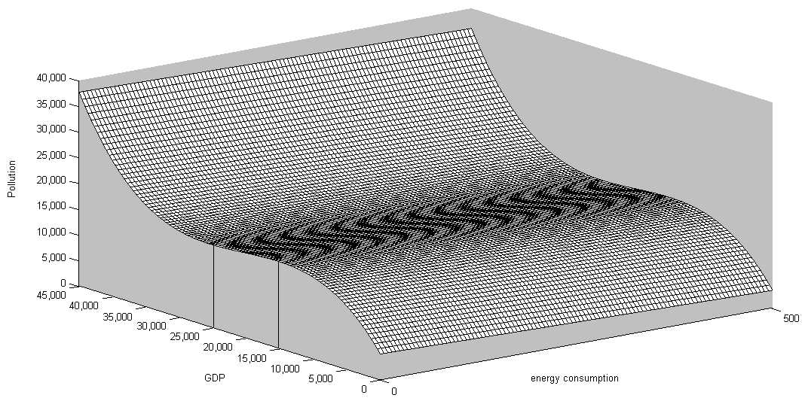

Figure 1. (Times New Roman, 10 pts, italic, bold, center) Figure title (Times New Roman, 10 pts, italic, center)
Source (Times New Roman, 10 pts, italic, centred):

- conclusion
The paper must be sent via e-mail in Word format document and will have the title with the following form: firstnameauthor_surnameauthor.doc, where the first name and the surname will be of the first author of the paper. The paper should be accompanied by the Copyright form which can be downloaded from the Journal website (http://www.jare-sh.com/documents/copyright_form.pdf).
The paper must comply with the format requirements that are given above and it is mandatory to have the following structure:
- Introduction - referring to the context of the research and the aims of the paper;
- Theoretical background or Literature review - including a theoretical presentation of the concepts used in the paper or an overview of the scientific literature in the field of the topic, presenting in a synthesized manner the most important references to the topic;
- Research methodology – detailing the research methods used by authors in obtaining results;
- Findings – pointing out the achieved results, in a structured manner;
- Conclusions - discussing the issue of validity, credibility, limits of the study, generalizing the data content etc.;
- References – the list of references will be prepared after journal requirements.
Authors can also add any chapters and subchapters designed to help the relevance of the paper.
References
Akbostanci, E., Türüt-Asik, S., et al. (2009). The relationship between income and environment in Turkey: Is there an environmental Kuznets curve?. Energy Policy, 37(3), 861–867.
Ang, J. B. (2007). CO₂ emissions, energy consumption, and output in France. Energy Policy, 35(10), 4772–4778.
Apergis, N. Payne, J. E. (2009). CO₂ emissions, energy usage, and output in Central America. Energy Policy, 37(8), 3282–3286.
Kuznets, S. (1955). Economic growth and income inequality. The American Economic Review, 45(1), 1–28.
Lee, C.-C., Chang, C.-P., et al. (2008). Energy-income causality in OECD countries revisited: The key role of capital stock. Energy Economics, 30(5), 2359–2373.
Levin, A., Lin, C.-F. (2002). Unit root tests in panel data: asymptotic and finite-sample properties. Journal of Econometrics, 108(1), 1–24.
Martínez-Zarzoso, I., Bengochea-Morancho, A. (2004). Pooled mean group estimation of an environmental Kuznets curve for CO2. Economics Letters 82(1), 121–126.
Masih, A.M.M., Masih, R. (1997). On the temporal causal relationship between energy consumption, real income, and prices: Some new evidence from Asian-energy dependent NICs Based on a multivariate cointegration/vector error-correction approach. Journal of Policy Modeling, 19(4), 417–440.
Mehrara, M. (2007). Energy consumption and economic growth: The case of oil exporting countries. Energy Policy, 35(5), 2939–2945.

Paper should not have more than three authors.
APA citation and reference style.

